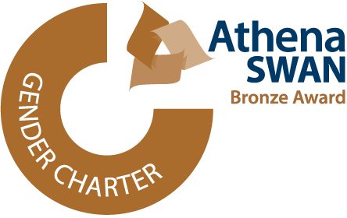
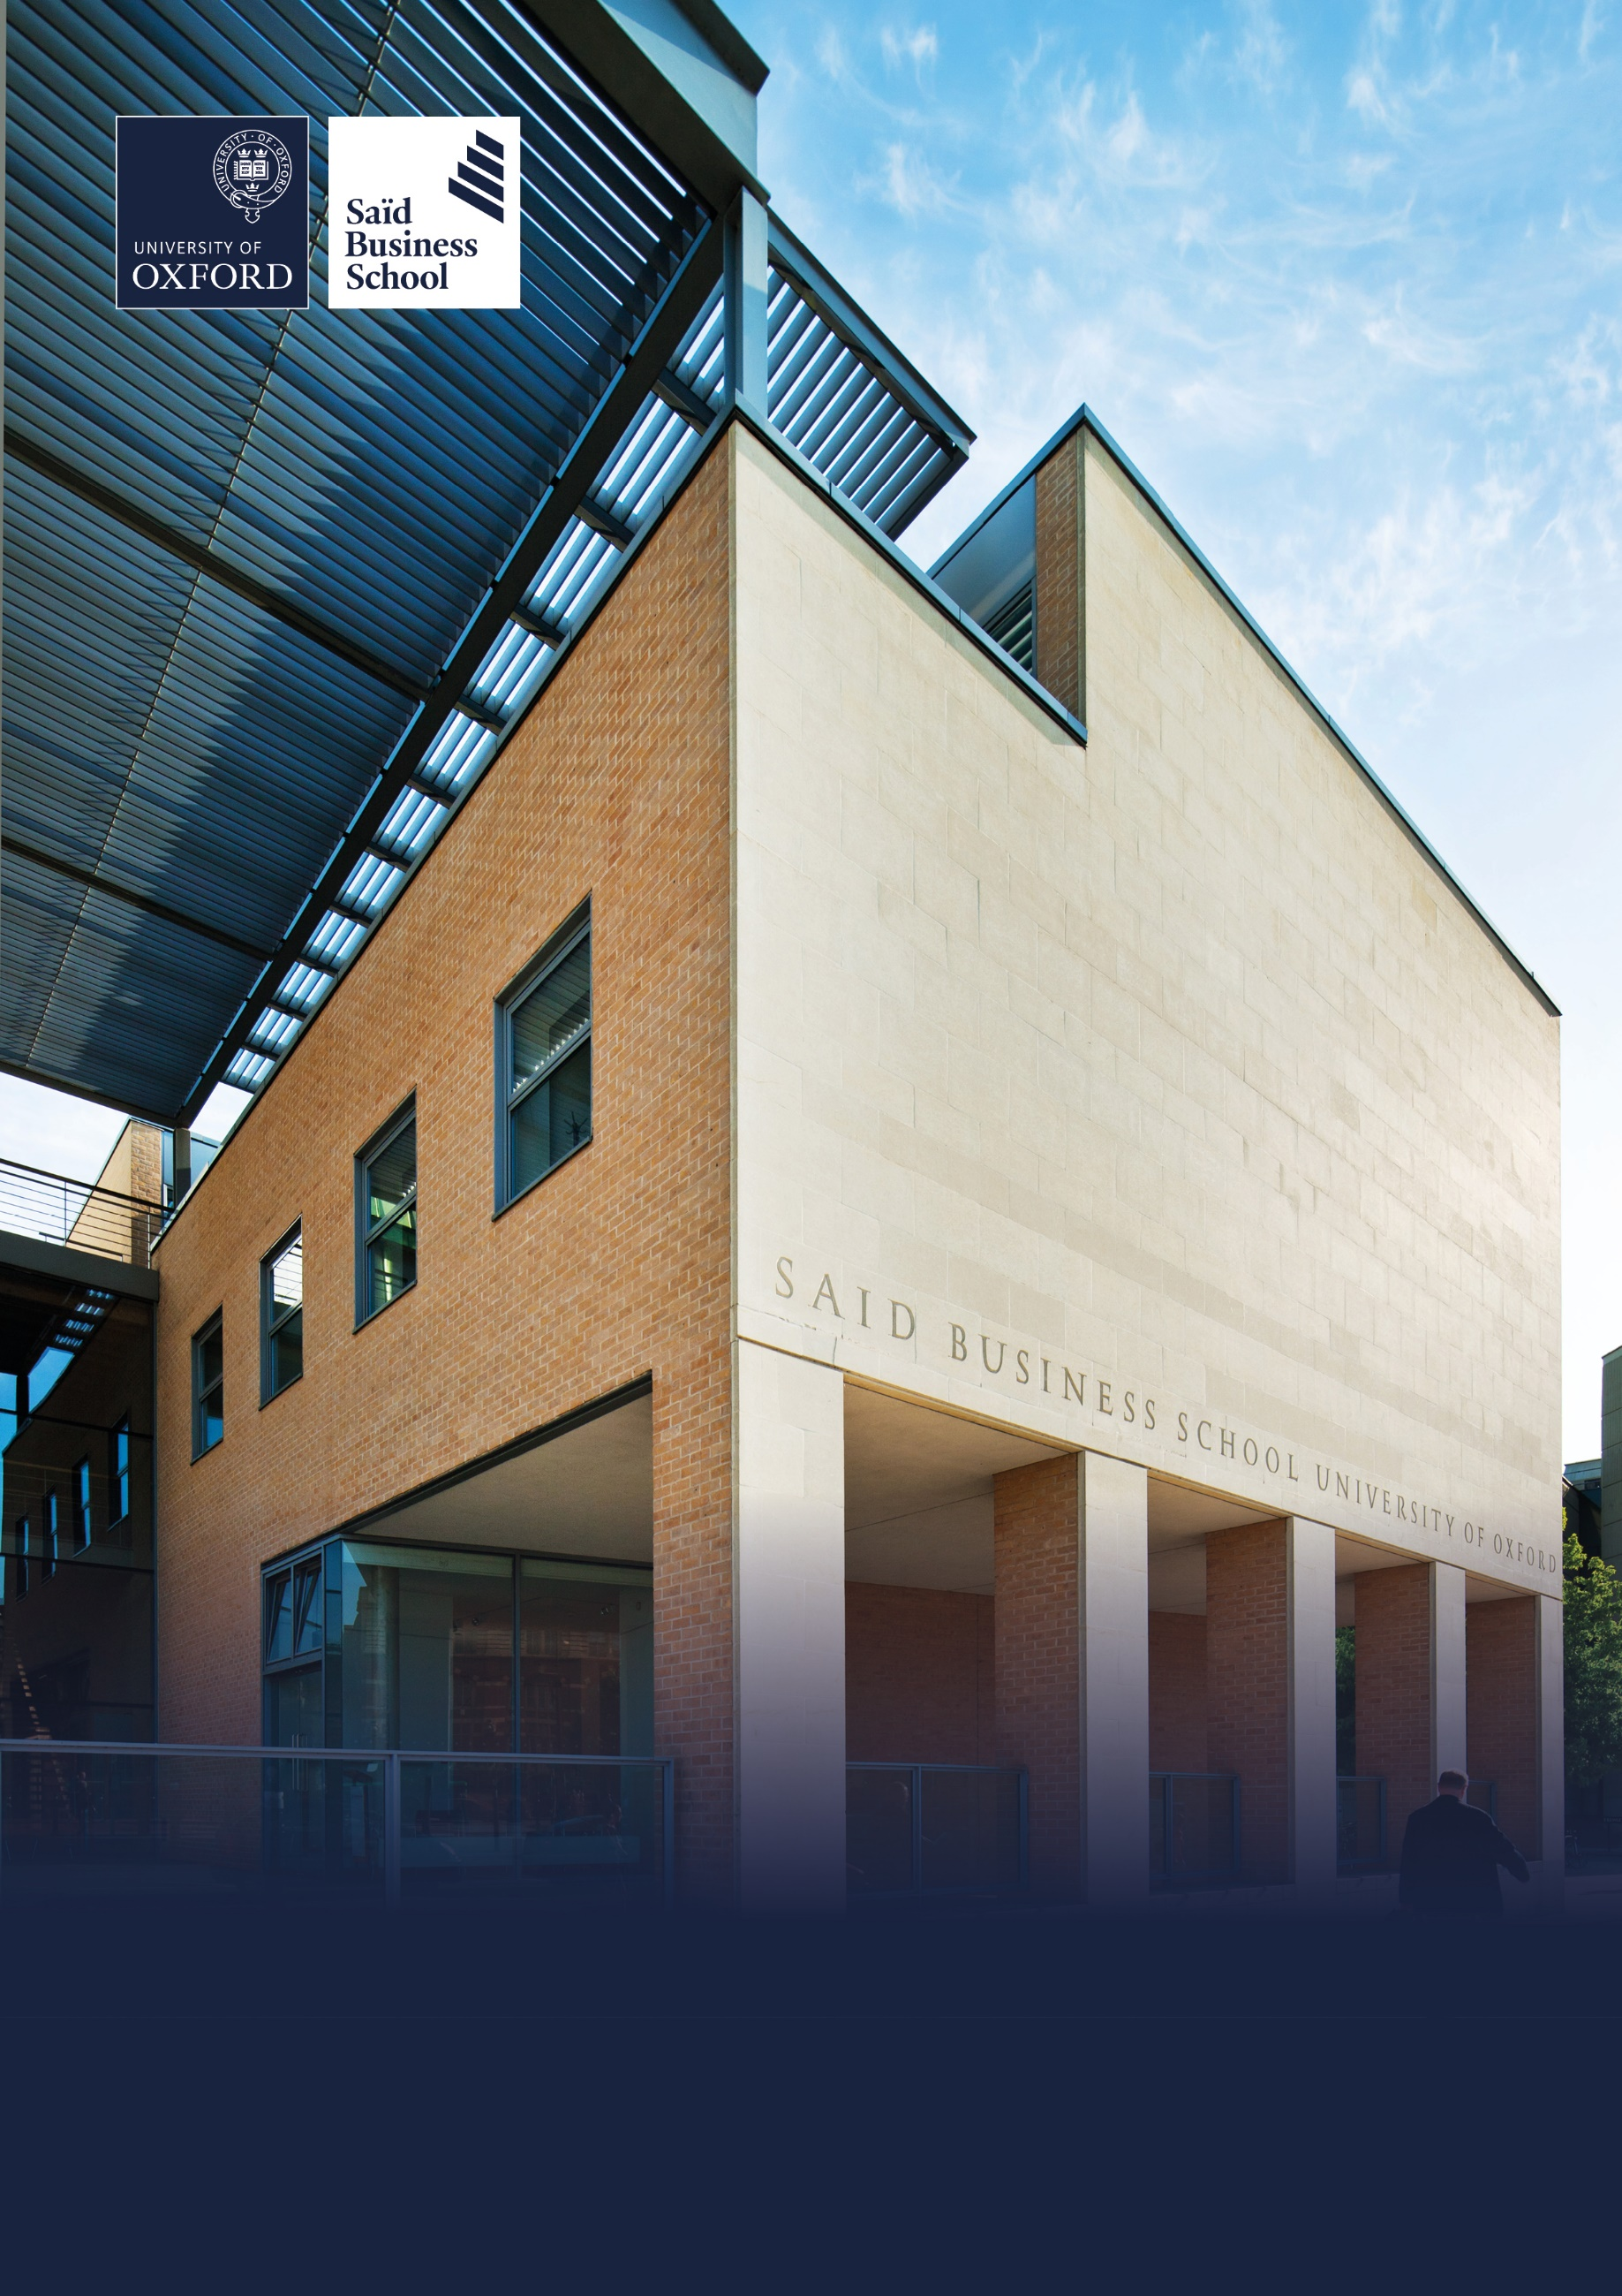

Hybrid (two days per week onsite), Global Leadership Centre and Park End Street, Oxford
Grade 7: £39,424 - £47,779 per annum including the Oxford University weighting of £1,730 per annum
Fixed-term (one year), full time (37.5 hours per week)
Reporting to: Programme Sales Manager, Sales & Customer Relations
Saïd Business School, Social Sciences Division, University of Oxford
Senior Programme Consultant


The role
The Sales and Customer Relations Team is the driving force in enabling Executive Education to
achieve its growth ambitions to double revenue in three years, and to realise its full potential as a
leading player in the global Executive Education market. Within this Team, the Programmes Sales
Team plays a critical role in ensuring the success and growth of Executive Education Open
Programmes to individuals seeking to benefit from our insights and expertise in developing their
leadership and career potential.

The Senior Programme Consultant is the first point of contact for executives approaching Executive
Education to obtain information on their options for a learning journey. The role holder is
responsible for the cultivation of a relationship with prospects, instigating conversation about their objectives and advising them to the most appropriate programme in our expanding portfolio of online executive education portfolio. The Senior Programme Consultant will be responsible for converting leads into
programme applications and a revenue in excess of £1.7m per year.

They will primarily work with individual executives looking for a programme for their own purposes.
They will gain knowledge across a range of programmes and delivery formats and advise
appropriately on all options. They will pass on opportunities for customised programmes, or from
Learning and Development Managers looking for programmes for groups of executives to relevant
colleagues across the Sales and Customer Relations team.

This role will involve liaising and collaborating with the Executive Education Marketing Team,
following up on the leads generated to develop relationships with prospects, participants and alumni.
The role will involve occasional travel, representing Executive Education and the wider school and
University, attending events and engaging in networking opportunities.

Responsibilities
- To be the first point of contact for online Executive Education programme enquiries, identifying the prospects’ interest and suitability.

- Taking forward the prioritised leads and making contact for further engagement, developing relationships with prospects.

- Conducting consultation calls to assess prospects’ interest and development objectives in a professional manner, advising them on programme content, experience and logistics.

- Advising prospects on the application process and next steps or passing them to an appropriate colleague, if required.

- Conduct consultation calls after an application is received and assess suitability for programme, recommending suitable next step or recommend alternative programme.

- Maintaining a database of prospects using the Saïd Business School Salesforce system, scoring incoming leads to prioritise for follow up, then tracking follow on communications

- Maintaining accurate lists of applicants across programmes, including receipt of payment to confirm the participant’s place, and supplying this to programme delivery colleagues, faculty and other colleagues.

- Developing knowledge of Oxford’s Executive Education offering and understanding of customer requirements to be able to recommend the appropriate programme or next steps. This will be a portfolio approach, product and format agnostic.

- Prepare recruitment reports, identifying and reporting trends across application or programme evaluation data to Programme Sales Manager, Programme Sales.


- Maintain excellent relationships with executive education alumni to increase referrals which benefit the portfolio or enhance our standing in the rankings, working closely where appropriate with the School’s Alumni Relations team.

- Continue to nurture partner / corporate relationships after the programme.

- Work closely with programme co-ordinators and the programme administration team, to enhance the participant experience.

- Contribute to the annual Business School rankings exercise.

- The Senior Programme Consultant will guide and develop Programme Consultants in their team. They will deputise for the Programme Sales Manager if required.

- Undertake other duties as appropriate to the grade and as required by the line manager.

Selection criteria

Essential selection criteria
- Business related degree or strong educational background.

- Evidence of prior success in a business development role, with demonstrated
ability to identify, establish and maintain relationships with executives and HR/L&D
professionals.

- Excellent oral and written communication skills with experience of writing and
presenting proposals.

- Team player, keen to work with internal/external team members to develop
outstanding results for the School.

- Willingness to travel internationally to attend events and client visits.

- Good personal and time management skills with the ability to prioritise workload in
a busy and sometimes pressured environment.

- Have a flexible approach to work and the duties to be carried out;

- Experience of using CRM software to track business development activities.
- Proven track record of success in a customer-facing role, with demonstrated ability to initiate relationships with Executives and take them through a full sales cycle.

- Proven track record in initiating relationships with key external stakeholders to create credible endorsement of a product / programme within external communities.

- A confident individual with proven good communication skills across internal and external stakeholders.

- Demonstrated understanding of sales and marketing, and an ability to work to meet targets in a focused way.

- First rate interpersonal and communication skills (both oral and written) and a proven ability to work with senior corporate contacts, external stakeholders and an academic community.

- An enthusiasm for meeting people and a cross-cultural awareness.

- Proven administrative and organisational skills, including proficiency in the use of Microsoft
Office programs including word, Excel and PowerPoint.

- Proven ability to use own initiative and to problem solve.

- Proven ability to perform work accurately with attention to detail.

- Experience of using CRM software to build and log business development activities.

- Excellent business awareness and commercial acumen.

- Strong analytical and project management skills.

Desirable selection criteria
- Experience of working in academic, executive development or professional training environments

- HND/degree or equivalent in a relevant discipline

- Experience in recruiting for online Executive Education programmes within an EdTech company or business school.

Pre-employment screening

Standard checks
If you are offered the post, the offer will be subject to standard pre-employment checks. You will be asked to provide: proof of your right-to-work in the UK; proof of your identity; and (if we haven’t done so already) we will contact the referees you have nominated. If you have previously worked for the University we will also verify key information such as your dates of employment and reason for leaving your previous role with the department/unit where you worked. You will also be asked to complete a health declaration so that you can tell us about any health conditions or disabilities for which you may need us to make appropriate adjustments.

Please read the candidate notes on the University’s pre-employment screening procedures at Pre-employment checks (https://www.ox.ac.uk/about/jobs/explore-our-careers/applications-process/pre-employment-screening).




About the University of Oxford
Welcome to the University of Oxford. We aim to lead the world in research and education for the benefit of society both in the UK and globally. Oxford’s researchers engage with academic, commercial and cultural partners across the world to stimulate high-quality research and enable innovation through a broad range of social, policy and economic impacts.

We believe our strengths lie both in empowering individuals and teams to address fundamental questions of global significance, while providing all our staff with a welcoming and inclusive workplace that enables everyone to develop and do their best work. Recognising that diversity is our strength, vital for innovation and creativity, we aspire to build a truly diverse community which values and respects every individual’s unique contribution.

While we have long traditions of scholarship, we are also forward-looking, creative and cutting-edge. Oxford is one of Europe’s most entrepreneurial universities and we rank first in the UK for university spin-outs, and in recent years we have spun out 15-20 new companies every year. We are also recognised as leaders in support for social enterprise.

Join us and you will find a unique, democratic and international community, a great range of staff benefits and access to a vibrant array of cultural activities in the beautiful city of Oxford. For more information, please visit About the University of Oxford (https://www.ox.ac.uk/about).

Saïd Business School
Saïd Business School blends the best of new and old. We are a vibrant and innovative business school, but yet deeply embedded in an 800 year old world-class university. We create programmes and ideas that have global impact. We educate people for successful business careers, and as a community seek to tackle world-scale problems.

We deliver cutting-edge programmes, including the highly regarded MBA, Executive MBA, a number of specialist MScs, a portfolio of custom and open programmes and accredited diplomas for executives, and we undertake ground-breaking research that transform individuals, organisations, business practice and society. We are an international and outward looking School with our programme participants coming from more than 50 countries.

We seek to be a world-class business school community, embedded in a world-class University, tackling world-scale problems.

Sustainability
Saïd Business School is committed to the highest standards of environmental sustainability, preserving the planet for future generations and acting in a socially sustainable manner. As an employee you are expected to uphold these commitments in accordance with our Environmental Policy. You can learn more about our organisation’s sustainability efforts at Sustainability | Saïd Business School (https://www.sbs.oxford.edu/about-us/school/sustainability).

Diversity and Inclusion
Oxford Saïd is committed to fostering an inclusive culture which promotes equality, values diversity and maintains a working, learning and social environment in which the rights and dignity of all its staff and students are respected. We recognise that the broad range of experiences that a diverse staff and student body brings strengthens our research and enhances our teaching, and that in order for Oxford to remain a world-leading institution we must continue to provide a diverse, inclusive, fair and open environment that allows everyone to grow and flourish.

Oxford Saïd holds a bronze Athena Swan award to recognise advancement of gender equality: representation, progression and success for all.

Our Values
To better understand our Values, what behaviours demonstrate them and how they are involved in your everyday work we have created the below descriptors.

Transformational
We challenge constructively, provoke thought, and influence and inspire others to develop.

Respectful
We are caring, supportive, appreciative, embrace difference and value each other's opinions.

Entrepreneurial
We embrace and encourage change and innovation. We are creative, flexible and brave.

Collaborative
We are stronger together. We are inclusive, approachable, listen to others and value good communication.

Purposeful

We are a community who believe in sustainable growth, and are responsible, principled and transparent.

Excellence
We are professional, focused and aligned, and have a responsibility to do the very best we can.

Wellbeing
Saïd Business School acknowledge the importance of wellbeing, in enabling people to thrive at work and ensure a work-life balance. It provides a number of initiatives to help support wellbeing and would encourage you to participate. At an individual level, wellbeing means recognising what helps us remain resilient and taking appropriate steps. If we experience difficulties, doing our best to rectify them and making our line manager aware of aspects that they could support us with.

Further information about Saïd Business School is available at Saïd Business School (www.sbs.oxford.edu).

Social Sciences
Oxford Saïd is a department within the Social Sciences Division, one of four academic Divisions in the University, each with considerable devolved budgetary and financial authority; and responsibility for providing a broad strategic focus across its constituent disciplines.

The Social Sciences Division represents the largest grouping of social sciences in the UK: home to a number of outstanding departments and to the internationally ranked Law Faculty; all are committed to research to develop a greater understanding of all aspects of society, from the impact of political, legal and economic systems on social and economic welfare to human rights and security. That research is disseminated through innovative graduate programmes and enhances undergraduate courses. For more information please visit Social Sciences Division (https://www.socsci.ox.ac.uk).

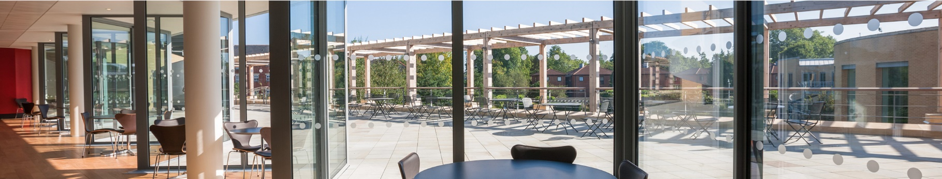
Important information for candidates

Data Privacy
Please note that any personal data submitted to the University as part of the job application process will be processed in accordance with the GDPR and related UK data protection legislation. For further information, please see the University’s Privacy Notice for Job Applicants at Job applicant privacy policy (https://compliance.admin.ox.ac.uk/job-applicant-privacy-policy).

The University’s Policy on Data Protection is available at Data protection policy (https://compliance.admin.ox.ac.uk/data-protection-policy).

The University’s policy on retirement
The University operates an Employer Justified Retirement Age (EJRA) for very senior research posts at grade RSIV/D35 and clinical equivalents E62 and E82 of 30 September before the 70th birthday.

For existing employees, any employment beyond the retirement age is subject to approval through the procedures. Please see The EJRA (https://unioxfordnexus.sharepoint.com/sites/OXINTRANET-working-here/SitePages/the-ejra.aspx).

There is no normal or fixed age at which staff in posts at other grades have to retire. Staff at these grades may elect to retire in accordance with the rules of the applicable pension scheme, as may be amended from time to time.

Equality of opportunity
The University of Oxford is committed to equal opportunity and to being a place where everyone belongs and is supported to succeed. We recognise how the diversity of our community enriches our ability to deliver on our academic mission.

We welcome applications from individuals from all backgrounds, including those underrepresented within higher education. No applicant or member of staff shall be unlawfully discriminated against on the basis of age, disability, gender reassignment, marriage or civil partnership, pregnancy or maternity, race, religion or belief, sex or sexual orientation.

Employment with the University and progression within employment will be determined according to personal merit and the application of criteria related to the duties and conditions of the post. In all cases, the primary consideration will be the ability to perform the job.

As stated in the University’s Equality Policy and Equality, Diversity and Inclusion Strategic Plan, our commitment to equality and diversity goes hand in hand with our commitment to academic freedom and free speech.


Oxford Saïd Exclusive Benefits

Wellbeing initiatives
Oxford Saïd runs a fortnightly Wellbeing Wednesday when staff are encouraged to take time (one hour for full-time staff and half an hour for part-time staff) during the working day to focus on their wellbeing in addition to their lunch break. We also have excellent catering facilities that provide a high standard of food, including healthy eating and vegetarian options at a subsidised cost.

Staff Summer and Christmas parties
Oxford Saïd like to reward all of their staff for their great work and their Christmas and Summer parties are our way of saying thank you. The Christmas party is for all staff and the summer party is for staff and their immediate family members, because we know how important family is to all of us.

Employee Assistance provider
Spectrum.Life is an employee assistance and wellbeing consultancy that works in partnership with the Business School to provide staff and their immediate family with a free 24-hour per day helpline providing confidential information and counselling services on personal issues.

University of Oxford Benefits

Annual leave
38 days (inc. public holidays). Long service additional annual leave – up to 5 days per annum, pro rata for part time employees. Previous service within higher education sector can be recognised. An additional scheme enables staff to request to purchase up to 10 additional days in each holiday year.

Salary and salary sacrifice schemes
The University salary and grading structure allows for annual incremental progression until a scale-bar point is reached. This incremental progression is automatic. Additionally, there are salary sacrifice schemes for bicycles and electric cars. See Working here (https://www.ox.ac.uk/about/jobs/working-here).

Pension
If you are on an academic or academic related pay scale (grade 6 or above), you are automatically a member of USS. Employer contribution is 14.5% and Employee contribution is 6.1%.

If you are on a pay scale other than academic or academic related (grade 1-5) you are automatically a member of OSPS. Employee contribution can be between 4%- 8% and Employer contribution 10%-14%.

University discounts
All University staff can purchase a TOTUM discount card for £14.99 for 12 months (£24.99 for 2 years, £34.99 for 3 years) which gives access to numerous exclusive offers and discounts from many popular retailers. There are a wide range of other discounts from external companies available using a university card.

University Club
Membership of the University Club is free for all University staff. The University Club offers social, sporting and hospitality facilities. Staff can also use the University Sports Centre on Iffley Road at discounted rates, including a fitness centre, powerlifting room and swimming pool. See The University Club (www.club.ox.ac.uk) and Oxford University Sport (https://www.sport.ox.ac.uk).

Access to Oxford buildings
Free access to a number of Oxford colleges, Botanic Gardens, Harcourt Arboretum, Wytham Woods and discount at numerous restaurants/shops.



Saïd Business School
University of Oxford
Park End Street
Oxford, OX1 1HP
Saïd Business School, University of Oxford
United Kingdom
www.sbs.oxford.edu

All information is correct at the time of going to press.

Please check our website for the most up-to-date information.

