
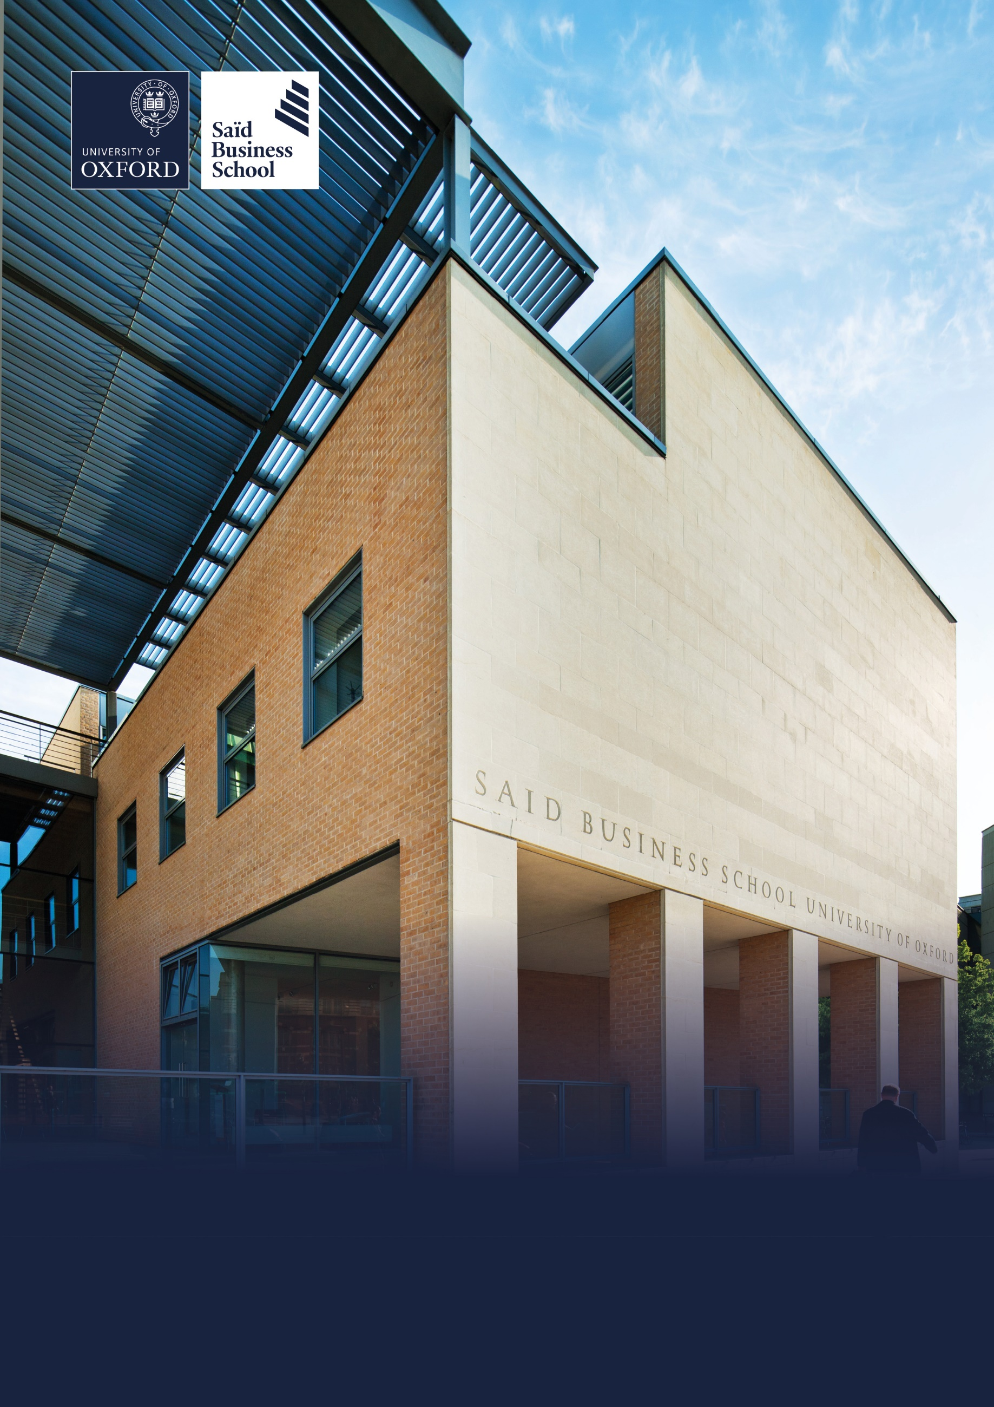

Hybrid (two days per week onsite), Egrove Park, Kennington and Park End Street, Oxford
Grade 5: £32,108 - £37,338 per annum including the Oxford University weighting of £1,730 per annum
Fixed-term (to 31 August 2027 with possible extension), full time (36.5 hours per week)
Reporting to: Associate Director
Saïd Business School, Social Sciences Division, University of Oxford
Programme Coordinator


The role
The Programme Coordinator plays a pivotal role in the successful operational delivery, online and in person, of the Goldman Sachs 10,000 Small Businesses UK programme.

Reporting to the Associate Director, the role works in close partnership with the Programme Manager, Curriculum & VLP Manager and wider programme team to coordinate the administration and operational delivery of residential, online and in-person programme activity.

The Programme Coordinator is responsible for ensuring that programme logistics, participant administration, operational systems and delivery processes are managed efficiently and to a consistently high standard, contributing to an outstanding experience for participants, faculty, speakers and stakeholders.

This is a varied and fast-paced role requiring excellent organisational skills, attention to detail and the ability to manage multiple priorities whilst working collaboratively across a number of teams.

The Programme Coordinator is responsible for ensuring the operational detail that underpins programme delivery is coordinated to an exceptional standard, enabling an outstanding experience for participants, faculty, speakers and stakeholders.

Responsibilities

Programme operations
- Coordinate the operational delivery of residential, online and in-person programme activities.

- Maintain programme delivery schedules, operational plans, checklists and trackers.

- Monitor progress against agreed deadlines and follow up outstanding actions.

- Identify operational risks or issues and escalate these appropriately.

- Support the Programme Manager and Associate Director in ensuring programme delivery runs efficiently across multiple concurrent workstreams.

Participant experience
- Maintain the shared programme inbox, responding to routine enquiries and ensuring issues are directed to the appropriate colleague where required.

- Act as the first point of contact for routine participant enquiries through the shared programme inbox.

- Coordinate participant communications, ensuring information is accurate, timely and professional.

- Support participant onboarding, registration, attendance monitoring and programme evaluations.

- Maintain accurate participant records throughout the programme lifecycle.

- Resolve day-to-day operational queries to ensure an excellent participant experience.

Operational delivery
- Coordinate all logistical aspects of residentials, online sessions and programme events.

- Arrange accommodation, catering, travel, venues and other operational requirements.

- Prepare programme materials, delegate packs and event documentation.

- Liaise with internal service teams including AV, IT, Catering, Housekeeping and Conferencing to ensure delivery requirements are met.

- Provide operational support during programme delivery, responding promptly to issues as they arise.


Faculty and speaker support
Working closely with the Curriculum & VLP Manager and Programme Manager:
- Coordinate operational arrangements for faculty, guest speakers and contributors.

- Arrange travel, accommodation and logistical requirements where required.

- Coordinate presentation materials and session resources.

- Ensure teaching spaces and online platforms are prepared for delivery.

- Provide operational support during programme delivery.

Systems and programme administration
- Maintain accurate programme information across systems including Canvas, Salesforce, Wrike and Microsoft 365.

- Maintain programme documentation, templates and operational procedures.

- Produce reports, trackers and administrative documentation to support programme delivery.

- Ensure programme records remain accurate, complete and up-to-date.

Financial administration
- Raise purchase orders and process programme invoices in accordance with University procedures.

- Maintain accurate expenditure records and financial trackers.

- Maintain expenditure records and provide accurate financial information to support programme monitoring, reporting and forecasting.

- Liaise with suppliers and Finance colleagues to resolve routine purchasing and invoicing queries.

Team working and continuous improvement
- Work collaboratively with colleagues across Recruitment, Curriculum, Alumni Relations and the School to support a seamless participant journey.

- Contribute to delivery meetings by recording actions and following up agreed activities.

- Identify opportunities to improve operational processes and participant experience.

- Support the implementation of agreed process improvements and contribute to the ongoing development of programme operations.

- Undertake other duties commensurate with the grade of the post.

Selection criteria

Essential selection criteria
- Experience coordinating operational activities, events or programmes involving multiple stakeholders

- Demonstrated ability to plan, prioritise and manage multiple competing tasks while meeting deadlines and quality standards.

- Outstanding attention to detail and accuracy.

- Excellent written and verbal communication skills.

- A proven track record of delivering excellent customer service and stakeholder support.

- High level of attention to detail, with a commitment to producing accurate documentation and maintaining high-quality operational processes.

- Self-motivated, adaptable and proactive, with the ability to use initiative, solve routine operational problems and contribute to continuous improvement.


- Strong interpersonal skills with the ability to build effective working relationships across multiple teams.

- Confident user of CRM or database systems (preferably Salesforce) and Microsoft Office applications, with the ability to learn new digital platforms quickly.

- Willingness to work flexibly, including occasional evenings and residential programme delivery.

Desirable selection criteria
- Experience working within Higher Education, Executive Education or professional learning environments.

- Experience using systems such as Canvas, Salesforce, Wrike or similar platforms.

- Knowledge of the SME business sector.

Pre-employment screening

Standard checks
If you are offered the post, the offer will be subject to standard pre-employment checks. You will be asked to provide: proof of your right-to-work in the UK; proof of your identity; and (if we haven’t done so already) we will contact the referees you have nominated. If you have previously worked for the University we will also verify key information such as your dates of employment and reason for leaving your previous role with the department/unit where you worked. You will also be asked to complete a health declaration so that you can tell us about any health conditions or disabilities for which you may need us to make appropriate adjustments.

Please read the candidate notes on the University’s pre-employment screening procedures at Pre-employment checks (https://hr.admin.ox.ac.uk/pre-employment-checks).


About the University of Oxford
Welcome to the University of Oxford. We aim to lead the world in research and education for the benefit of society both in the UK and globally. Oxford’s researchers engage with academic, commercial and cultural partners across the world to stimulate high-quality research and enable innovation through a broad range of social, policy and economic impacts.

We believe our strengths lie both in empowering individuals and teams to address fundamental questions of global significance, while providing all our staff with a welcoming and inclusive workplace that enables everyone to develop and do their best work. Recognising that diversity is our strength, vital for innovation and creativity, we aspire to build a truly diverse community which values and respects every individual’s unique contribution.

While we have long traditions of scholarship, we are also forward-looking, creative and cutting-edge. Oxford is one of Europe’s most entrepreneurial universities and we rank first in the UK for university spin-outs, and in recent years we have spun out 15-20 new companies every year. We are also recognised as leaders in support for social enterprise.

Join us and you will find a unique, democratic and international community, a great range of staff benefits and access to a vibrant array of cultural activities in the beautiful city of Oxford. For more information, please visit How we are run (https://www.ox.ac.uk/about/how-we-are-run).

Saïd Business School
Saïd Business School blends the best of new and old. We are a vibrant and innovative business school, but yet deeply embedded in an 800 year old world-class university. We create programmes and ideas that have global impact. We educate people for successful business careers, and as a community seek to tackle world-scale problems.

We deliver cutting-edge programmes, including the highly regarded MBA, Executive MBA, a number of specialist MScs, a portfolio of custom and open programmes and accredited diplomas for executives, and we undertake ground-breaking research that transform individuals, organisations, business practice and society. We are an international and outward looking School with our programme participants coming from more than 50 countries.

We seek to be a world-class business school community, embedded in a world-class University, tackling world-scale problems.

Sustainability
Saïd Business School is committed to the highest standards of environmental sustainability, preserving the planet for future generations and acting in a socially sustainable manner. As an employee you are expected to uphold these commitments in accordance with our Environmental Policy. You can learn more about our organisation’s sustainability efforts at Sustainability | Saïd Business School (https://www.sbs.oxford.edu/about-us/school/sustainability).

Diversity and Inclusion
Oxford Saïd is committed to fostering an inclusive culture which promotes equality, values diversity and maintains a working, learning and social environment in which the rights and dignity of all its staff and students are respected. We recognise that the broad range of experiences that a diverse staff and student body brings strengthens our research and enhances our teaching, and that in order for Oxford to remain a world-leading institution we must continue to provide a diverse, inclusive, fair and open environment that allows everyone to grow and flourish.

Oxford Saïd holds a bronze Athena Swan award to recognise advancement of gender equality: representation, progression and success for all.

Our Values
To better understand our Values, what behaviours demonstrate them and how they are involved in your everyday work we have created the below descriptors.

Transformational
We challenge constructively, provoke thought, and influence and inspire others to develop.

Respectful
We are caring, supportive, appreciative, embrace difference and value each other's opinions.

Entrepreneurial
We embrace and encourage change and innovation. We are creative, flexible and brave.

Collaborative
We are stronger together. We are inclusive, approachable, listen to others and value good communication.

Purposeful

We are a community who believe in sustainable growth, and are responsible, principled and transparent.

Excellence
We are professional, focused and aligned, and have a responsibility to do the very best we can.

Wellbeing
Saïd Business School acknowledge the importance of wellbeing, in enabling people to thrive at work and ensure a work-life balance. It provides a number of initiatives to help support wellbeing and would encourage you to participate. At an individual level, wellbeing means recognising what helps us remain resilient and taking appropriate steps. If we experience difficulties, doing our best to rectify them and making our line manager aware of aspects that they could support us with.

Further information about Saïd Business School is available at Saïd Business School (www.sbs.oxford.edu).

Social Sciences
Oxford Saïd is a department within the Social Sciences Division, one of four academic Divisions in the University, each with considerable devolved budgetary and financial authority; and responsibility for providing a broad strategic focus across its constituent disciplines.

The Social Sciences Division represents the largest grouping of social sciences in the UK: home to a number of outstanding departments and to the internationally ranked Law Faculty; all are committed to research to develop a greater understanding of all aspects of society, from the impact of political, legal and economic systems on social and economic welfare to human rights and security. That research is disseminated through innovative graduate programmes and enhances undergraduate courses. For more information please visit Social Sciences Division (https://www.socsci.ox.ac.uk).


Important information for candidates

Data Privacy
Please note that any personal data submitted to the University as part of the job application process will be processed in accordance with the GDPR and related UK data protection legislation. For further information, please see the University’s Privacy Notice for Job Applicants at Job applicant privacy policy (https://compliance.admin.ox.ac.uk/job-applicant-privacy-policy).

The University’s Policy on Data Protection is available at Data protection policy (https://compliance.admin.ox.ac.uk/data-protection-policy).

The University’s policy on retirement
The University operates an Employer Justified Retirement Age (EJRA) for very senior research posts at grade RSIV/D35 and clinical equivalents E62 and E82 of 30 September before the 70th birthday. The justification for this is explained at The EJRA (https://hr.admin.ox.ac.uk/the-ejra).

For existing employees, any employment beyond the retirement age is subject to approval through the procedures. Please see The EJRA (https://hr.admin.ox.ac.uk/the-ejra).

There is no normal or fixed age at which staff in posts at other grades have to retire. Staff at these grades may elect to retire in accordance with the rules of the applicable pension scheme, as may be amended from time to time.

Equality of opportunity
The University of Oxford is committed to equal opportunity and to being a place where everyone belongs and is supported to succeed. We recognise how the diversity of our community enriches our ability to deliver on our academic mission.

We welcome applications from individuals from all backgrounds, including those underrepresented within higher education. No applicant or member of staff shall be unlawfully discriminated against on the basis of age, disability, gender reassignment, marriage or civil partnership, pregnancy or maternity, race, religion or belief, sex or sexual orientation.

Employment with the University and progression within employment will be determined according to personal merit and the application of criteria related to the duties and conditions of the post. In all cases, the primary consideration will be the ability to perform the job.

As stated in the University’s Equality Policy and Equality, Diversity and Inclusion Strategic Plan, our commitment to equality and diversity goes hand in hand with our commitment to academic freedom and free speech.


Oxford Saïd Exclusive Benefits

Wellbeing initiatives
Oxford Saïd runs an annual Wellbeing Day for all staff. In addition to this, there is yoga, healthy food deliveries, health MOTs and a range of other ad hoc programmes. Our excellent catering facilities provide a high standard of food, including healthy eating and vegetarian options at a subsidised cost.

Staff Summer and Christmas parties
Oxford Saïd like to reward all of their staff for their great work and their Christmas and Summer parties are our way of saying thank you. The Christmas party is for all staff and the summer party is for staff and their immediate family members, because we know how important family is to all of us.

Employee Assistance provider
Spectrum.Life is an employee assistance and wellbeing consultancy that works in partnership with the Business School to provide staff and their immediate family with a free 24-hour per day helpline providing confidential information and counselling services on personal issues.

University of Oxford Benefits

Annual leave
38 days (inc. public holidays). Long service additional annual leave – up to 5 days per annum, pro rata for part time employees. Previous service within higher education sector can be recognised. An additional scheme enables staff to request to purchase up to 10 additional days in each holiday year.

Salary and salary sacrifice schemes
The University salary and grading structure allows for annual incremental progression until a scale-bar point is reached. This incremental progression is automatic. Additionally, there are salary sacrifice schemes for bicycles and electric cars. See Staff benefits (https://hr.admin.ox.ac.uk/staff-benefits).

Pension
If you are on an academic or academic related pay scale (grade 6 or above), you are automatically a member of USS. Employer contribution is 14.5% and Employee contribution is 6.1%.

If you are on a pay scale other than academic or academic related (grade 1-5) you are automatically a member of OSPS. Employee contribution can be between 4%- 8% and Employer contribution 10%-14%.

University discounts
All University staff can purchase a TOTUM discount card for £14.99 for 12 months (£24.99 for 2 years, £34.99 for 3 years) which gives access to numerous exclusive offers and discounts from many popular retailers. There are a wide range of other discounts from external companies available using a university card.

University Club
Membership of the University Club is free for all University staff. The University Club offers social, sporting and hospitality facilities. Staff can also use the University Sports Centre on Iffley Road at discounted rates, including a fitness centre, powerlifting room and swimming pool. See The University Club (www.club.ox.ac.uk) and Oxford University Sport (https://www.sport.ox.ac.uk).

Access to Oxford buildings
Free access to a number of Oxford colleges, Botanic Gardens, Harcourt Arboretum, Wytham Woods and discount at numerous restaurants/shops.



Saïd Business School
University of Oxford
Park End Street
Oxford, OX1 1HP
Saïd Business School, University of Oxford
United Kingdom
www.sbs.oxford.edu

All information is correct at the time of going to press.

Please check our website for the most up-to-date information.

