
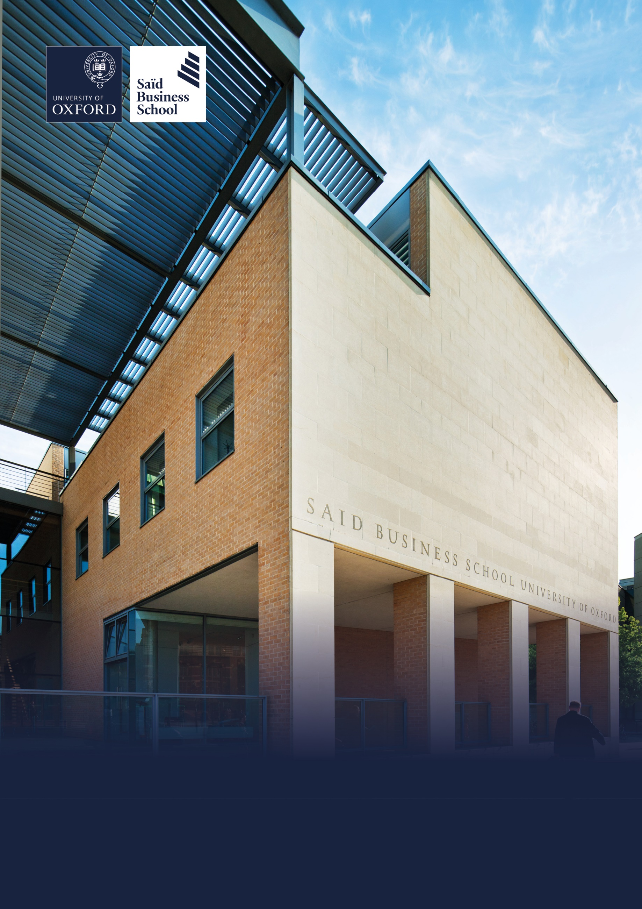

Hybrid (two days per week onsite), Global Leadership Centre and Park End Street, Oxford
Grade 8: £49,119 - £58,265 per annum including the Oxford University weighting of £1,730 per annum
Permanent, full time (37.5 hours per week)
Reporting to: Learning Innovation and Community Director
Saïd Business School, Social Sciences Division, University of Oxford
Learning Innovation and Community Manager


The role
The success of Executive Education depends on the quality of the people who design and deliver our programmes. This role is central to building the academic and professional contributor community that enables Oxford Saïd to deliver exceptional learning experiences for organisations and individuals around the world.

The Learning Innovation and Community Manager plays a key role in building and strengthening the relationships that underpin our Executive Education portfolio. Working as part of the Learning, Impact and Product Innovation team, you will help ensure we have the right people, expertise and engagement to support a growing portfolio of custom and open programmes.

Reporting to the Learning Innovation and Community Director, you will work closely with colleagues across Executive Education, faculty from Saïd Business School and the wider University of Oxford, and our external Programme Director community. You will manage the identification and engagement of Academic Directors and Programme Directors for new opportunities, support the development of our contributor communities, and help build a deeper understanding of academic capability across the University.

You will translate the Learning Innovation and Community strategy into effective operational delivery, ensuring contributor engagement, deployment, community systems and ways of working are implemented consistently across Executive Education.

This is a highly collaborative, relationship-focused role for someone who enjoys working with people. Success depends on your ability to build trusted relationships with senior academics, experienced practitioners and colleagues across the School, while balancing commercial priorities with excellent stakeholder engagement, sound judgement and a commitment to continuous improvement.

Alongside relationship management, you will lead the continuous improvement of the systems, processes and operational workflows that support our learning communities. You will thrive in an evolving environment, improving consistency, efficiency and collaboration while ensuring Executive Education continues to deliver programmes of the highest quality.

At its heart, this role is about bringing together exceptional people to create exceptional learning experiences. If you enjoy building trusted relationships, connecting expertise with opportunity and helping others succeed, this is an opportunity to make a lasting contribution to Oxford Saïd's Executive Education community and the impact it creates around the world.

Responsibilities

Academic Director and Programme Director engagement
- Manage the identification and selection of Academic Directors and Programme Directors for Executive Education's portfolio of custom and open programmes.

- Work closely with client teams to understand programme requirements and identify the most appropriate academic and practitioner expertise for each opportunity.

- Build trusted relationships with faculty from Saïd Business School, the wider University of Oxford and our external Programme Director community.

- Manage the operational delivery and continuous improvement of Expressions of Interest, contributor selection processes and associated communications, ensuring a consistent, efficient and positive contributor experience.

- Communicate with clarity, empathy and professionalism throughout the selection process, ensuring contributors are well informed and have confidence in their experience.

- Exercise sound judgement when balancing stakeholder needs, programme requirements and commercial priorities.


Faculty capability and community development
- Develop and maintain a comprehensive understanding of academic expertise across the University of Oxford to support current and future Executive Education opportunities.

- Build relationships with departments, faculties, research centres and institutes across the University, identifying opportunities to broaden Executive Education's academic network.

- Maintain an up-to-date understanding of faculty capability, interests and experience to support programme development and future planning.

- Support the Learning Innovation and Community Director in developing and maintaining a diverse pipeline of academic and practitioner talent, helping to identify future contributors and strengthen Executive Education's long-term capability.

- Demonstrate curiosity by actively seeking to understand emerging areas of expertise, new research and opportunities for collaboration across the University.

Learning community engagement
- Support the delivery of engagement strategies for our faculty, Academic Director and Programme Director communities.

- Plan, organise and coordinate a regular programme of meetings, briefings and engagement activities that keep contributors informed, connected and engaged.

- Work closely with the Learning Innovation and Impact Coordinator to ensure engagement activities are delivered effectively.

- Help foster an inclusive, collaborative and connected contributor community where people feel valued, informed and motivated to contribute.

- Build an understanding of our contributor communities, recognising emerging opportunities, levels of engagement and areas where additional support may be beneficial.

- Contribute to building a positive and collaborative One Executive Education culture through every interaction with our contributor communities.

- Monitor engagement, participation and stakeholder feedback, using insight and data to continuously improve contributor experience, community effectiveness and engagement activities.

Stakeholder relationship management
- Build productive relationships with colleagues across Executive Education, ensuring effective collaboration between client, commercial, product and programme delivery teams.

- Establish credibility quickly with senior academics, experienced practitioners and colleagues across the University.

- Influence and build consensus with stakeholders where there is no direct line management responsibility.

- Act as a trusted point of contact for faculty, Programme Directors and prospective contributors, providing a responsive, professional and welcoming experience.

- Manage speculative enquiries from individuals interested in contributing to Executive Education, assessing opportunities and ensuring a positive experience for prospective contributors.

- Represent Executive Education professionally, acting as an ambassador for the School and strengthening relationships across the wider University and beyond.

- Handle sensitive conversations with diplomacy, openness and professionalism, maintaining positive relationships even when delivering difficult messages.

- Recognise that every interaction contributes to the reputation of Executive Education and consistently deliver an excellent stakeholder experience.

- Manage the day-to-day operation of Executive Education's contributor relationships, ensuring timely deployment, effective communication and responsive issue resolution across the programme portfolio.

Operational coordination
- Coordinate the operational deployment of Academic Directors, Programme Directors and contributors across Executive Education programmes, ensuring appropriate expertise is aligned to programme requirements.

- Ensure contributor information, communications and operational records are accurate, current and accessible.

- Work closely with client, product, commercial and delivery teams to ensure contributor activities are coordinated effectively across the programme lifecycle.

- Identify operational risks, issues and dependencies, escalating where appropriate and helping to develop practical solutions.

Continuous improvement and operational excellence
- Lead the continuous improvement of contributor engagement systems, operational processes and workflows, improving consistency, efficiency, scalability and stakeholder experience across Executive Education.

- Help develop practical guidance, resources and tools that improve consistency, collaboration and operational effectiveness.

- Maintain accurate records and ensure information is managed effectively to support decision making and future planning.

- Contribute to projects that strengthen the capability and effectiveness of the Learning, Impact and Product Innovation team.

- Work confidently in a changing environment, adapting to evolving priorities while maintaining a consistently high standard of delivery.

Collaboration across Executive Education
- Work collaboratively across the Learning, Impact and Product Innovation team, ensuring activities align with wider team priorities and Executive Education strategy.

- Maintain a strong understanding of developments across Executive Education so that contributor activity remains aligned with wider priorities and ways of working.

- Ensure the right people receive the right information at the right time, supporting effective collaboration across teams.

- Build strong working relationships across Executive Education, contributing to a culture of openness, collaboration and shared purpose.

- Undertake other duties as appropriate to the grade and as required eg by line manager.

Selection criteria

Essential selection criteria
- Demonstrable experience of building and maintaining trusted relationships with senior stakeholders, with the ability to influence and build credibility where there is no direct line management responsibility.

- Excellent interpersonal and communication skills, with the ability to communicate clearly, accurately and professionally in both written and spoken English, adapting your approach to different audiences.

- Experience of coordinating complex operational activities involving multiple stakeholders, with strong organisational skills, sound judgement and the ability to deliver high-quality work to competing deadlines.

- Experience of leading or supporting the continuous improvement of systems, processes or ways of working to enhance operational effectiveness and stakeholder experience.

- Ability to work collaboratively across teams within a complex organisation, building effective partnerships and contributing to shared organisational objectives.

- Commercial awareness and the ability to balance stakeholder needs with organisational priorities when making decisions and delivering outcomes.

- A proactive and curious approach to building relationships, developing networks and identifying opportunities within a complex environment, together with the ability to manage ambiguity and respond positively to change.

- Degree-level qualification or equivalent professional experience.

Desirable selection criteria
- Experience of working within higher education, executive education or another knowledge-intensive environment involving engagement with senior academic or professional stakeholders.

- Understanding of the structure, culture and governance of research-intensive universities, particularly the University of Oxford or a comparable institution.

- Experience of community building, contributor engagement, talent identification or capability mapping across diverse stakeholder groups.

- Experience of supporting organisational change, transformation or continuous improvement initiatives.

Pre-employment screening

Standard checks
If you are offered the post, the offer will be subject to standard pre-employment checks. You will be asked to provide: proof of your right-to-work in the UK; proof of your identity; and (if we haven’t done so already) we will contact the referees you have nominated. If you have previously worked for the University we will also verify key information such as your dates of employment and reason for leaving your previous role with the department/unit where you worked. You will also be asked to complete a health declaration so that you can tell us about any health conditions or disabilities for which you may need us to make appropriate adjustments.

Please read the candidate notes on the University’s pre-employment screening procedures at Pre-employment checks (https://www.ox.ac.uk/about/jobs/explore-our-careers/applications-process/pre-employment-screening).



About the University of Oxford
Welcome to the University of Oxford. We aim to lead the world in research and education for the benefit of society both in the UK and globally. Oxford’s researchers engage with academic, commercial and cultural partners across the world to stimulate high-quality research and enable innovation through a broad range of social, policy and economic impacts.

We believe our strengths lie both in empowering individuals and teams to address fundamental questions of global significance, while providing all our staff with a welcoming and inclusive workplace that enables everyone to develop and do their best work. Recognising that diversity is our strength, vital for innovation and creativity, we aspire to build a truly diverse community which values and respects every individual’s unique contribution.

While we have long traditions of scholarship, we are also forward-looking, creative and cutting-edge. Oxford is one of Europe’s most entrepreneurial universities and we rank first in the UK for university spin-outs, and in recent years we have spun out 15-20 new companies every year. We are also recognised as leaders in support for social enterprise.

Join us and you will find a unique, democratic and international community, a great range of staff benefits and access to a vibrant array of cultural activities in the beautiful city of Oxford. For more information, please visit About the University of Oxford (https://www.ox.ac.uk/about).

Saïd Business School
Saïd Business School blends the best of new and old. We are a vibrant and innovative business school, but yet deeply embedded in an 800 year old world-class university. We create programmes and ideas that have global impact. We educate people for successful business careers, and as a community seek to tackle world-scale problems.

We deliver cutting-edge programmes, including the highly regarded MBA, Executive MBA, a number of specialist MScs, a portfolio of custom and open programmes and accredited diplomas for executives, and we undertake ground-breaking research that transform individuals, organisations, business practice and society. We are an international and outward looking School with our programme participants coming from more than 50 countries.

We seek to be a world-class business school community, embedded in a world-class University, tackling world-scale problems.

Sustainability
Saïd Business School is committed to the highest standards of environmental sustainability, preserving the planet for future generations and acting in a socially sustainable manner. As an employee you are expected to uphold these commitments in accordance with our Environmental Policy. You can learn more about our organisation’s sustainability efforts at Sustainability | Saïd Business School (https://www.sbs.oxford.edu/about-us/school/sustainability).

Diversity and Inclusion
Oxford Saïd is committed to fostering an inclusive culture which promotes equality, values diversity and maintains a working, learning and social environment in which the rights and dignity of all its staff and students are respected. We recognise that the broad range of experiences that a diverse staff and student body brings strengthens our research and enhances our teaching, and that in order for Oxford to remain a world-leading institution we must continue to provide a diverse, inclusive, fair and open environment that allows everyone to grow and flourish.

Oxford Saïd holds a bronze Athena Swan award to recognise advancement of gender equality: representation, progression and success for all.

Our Values
To better understand our Values, what behaviours demonstrate them and how they are involved in your everyday work we have created the below descriptors.

Transformational
We challenge constructively, provoke thought, and influence and inspire others to develop.

Respectful
We are caring, supportive, appreciative, embrace difference and value each other's opinions.

Entrepreneurial
We embrace and encourage change and innovation. We are creative, flexible and brave.

Collaborative
We are stronger together. We are inclusive, approachable, listen to others and value good communication.

Purposeful

We are a community who believe in sustainable growth, and are responsible, principled and transparent.

Excellence
We are professional, focused and aligned, and have a responsibility to do the very best we can.

Wellbeing
Saïd Business School acknowledge the importance of wellbeing, in enabling people to thrive at work and ensure a work-life balance. It provides a number of initiatives to help support wellbeing and would encourage you to participate. At an individual level, wellbeing means recognising what helps us remain resilient and taking appropriate steps. If we experience difficulties, doing our best to rectify them and making our line manager aware of aspects that they could support us with.

Further information about Saïd Business School is available at Saïd Business School (www.sbs.oxford.edu).

Social Sciences
Oxford Saïd is a department within the Social Sciences Division, one of four academic Divisions in the University, each with considerable devolved budgetary and financial authority; and responsibility for providing a broad strategic focus across its constituent disciplines.

The Social Sciences Division represents the largest grouping of social sciences in the UK: home to a number of outstanding departments and to the internationally ranked Law Faculty; all are committed to research to develop a greater understanding of all aspects of society, from the impact of political, legal and economic systems on social and economic welfare to human rights and security. That research is disseminated through innovative graduate programmes and enhances undergraduate courses. For more information please visit Social Sciences Division (https://www.socsci.ox.ac.uk).


Important information for candidates

Data Privacy
Please note that any personal data submitted to the University as part of the job application process will be processed in accordance with the GDPR and related UK data protection legislation. For further information, please see the University’s Privacy Notice for Job Applicants at Job applicant privacy policy (https://compliance.admin.ox.ac.uk/job-applicant-privacy-policy).

The University’s Policy on Data Protection is available at Data protection policy (https://compliance.admin.ox.ac.uk/data-protection-policy).

The University’s policy on retirement
The University operates an Employer Justified Retirement Age (EJRA) for very senior research posts at grade RSIV/D35 and clinical equivalents E62 and E82 of 30 September before the 70th birthday.

For existing employees, any employment beyond the retirement age is subject to approval through the procedures. Please see The EJRA (https://unioxfordnexus.sharepoint.com/sites/OXINTRANET-working-here/SitePages/the-ejra.aspx).

There is no normal or fixed age at which staff in posts at other grades have to retire. Staff at these grades may elect to retire in accordance with the rules of the applicable pension scheme, as may be amended from time to time.

Equality of opportunity
The University of Oxford is committed to equal opportunity and to being a place where everyone belongs and is supported to succeed. We recognise how the diversity of our community enriches our ability to deliver on our academic mission.

We welcome applications from individuals from all backgrounds, including those underrepresented within higher education. No applicant or member of staff shall be unlawfully discriminated against on the basis of age, disability, gender reassignment, marriage or civil partnership, pregnancy or maternity, race, religion or belief, sex or sexual orientation.

Employment with the University and progression within employment will be determined according to personal merit and the application of criteria related to the duties and conditions of the post. In all cases, the primary consideration will be the ability to perform the job.

As stated in the University’s Equality Policy and Equality, Diversity and Inclusion Strategic Plan, our commitment to equality and diversity goes hand in hand with our commitment to academic freedom and free speech.


Oxford Saïd Exclusive Benefits

Wellbeing initiatives
Oxford Saïd runs a fortnightly Wellbeing Wednesday when staff are encouraged to take time (one hour for full-time staff and half an hour for part-time staff) during the working day to focus on their wellbeing in addition to their lunch break. We also have excellent catering facilities that provide a high standard of food, including healthy eating and vegetarian options at a subsidised cost.

Staff Summer and Christmas parties
Oxford Saïd like to reward all of their staff for their great work and their Christmas and Summer parties are our way of saying thank you. The Christmas party is for all staff and the summer party is for staff and their immediate family members, because we know how important family is to all of us.

Employee Assistance provider
Spectrum.Life is an employee assistance and wellbeing consultancy that works in partnership with the Business School to provide staff and their immediate family with a free 24-hour per day helpline providing confidential information and counselling services on personal issues.

University of Oxford Benefits

Annual leave
38 days (inc. public holidays). Long service additional annual leave – up to 5 days per annum, pro rata for part time employees. Previous service within higher education sector can be recognised. An additional scheme enables staff to request to purchase up to 10 additional days in each holiday year.

Salary and salary sacrifice schemes
The University salary and grading structure allows for annual incremental progression until a scale-bar point is reached. This incremental progression is automatic. Additionally, there are salary sacrifice schemes for bicycles and electric cars. See Working here (https://www.ox.ac.uk/about/jobs/working-here).

Pension
If you are on an academic or academic related pay scale (grade 6 or above), you are automatically a member of USS. Employer contribution is 14.5% and Employee contribution is 6.1%.

If you are on a pay scale other than academic or academic related (grade 1-5) you are automatically a member of OSPS. Employee contribution can be between 4%- 8% and Employer contribution 10%-14%.

University discounts
All University staff can purchase a TOTUM discount card for £14.99 for 12 months (£24.99 for 2 years, £34.99 for 3 years) which gives access to numerous exclusive offers and discounts from many popular retailers. There are a wide range of other discounts from external companies available using a university card.

University Club
Membership of the University Club is free for all University staff. The University Club offers social, sporting and hospitality facilities. Staff can also use the University Sports Centre on Iffley Road at discounted rates, including a fitness centre, powerlifting room and swimming pool. See The University Club (www.club.ox.ac.uk) and Oxford University Sport (https://www.sport.ox.ac.uk).

Access to Oxford buildings
Free access to a number of Oxford colleges, Botanic Gardens, Harcourt Arboretum, Wytham Woods and discount at numerous restaurants/shops.



Saïd Business School
University of Oxford
Park End Street
Oxford, OX1 1HP
Saïd Business School, University of Oxford
United Kingdom
www.sbs.oxford.edu

All information is correct at the time of going to press.

Please check our website for the most up-to-date information.

