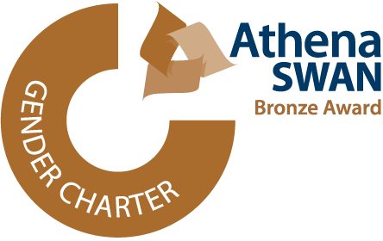
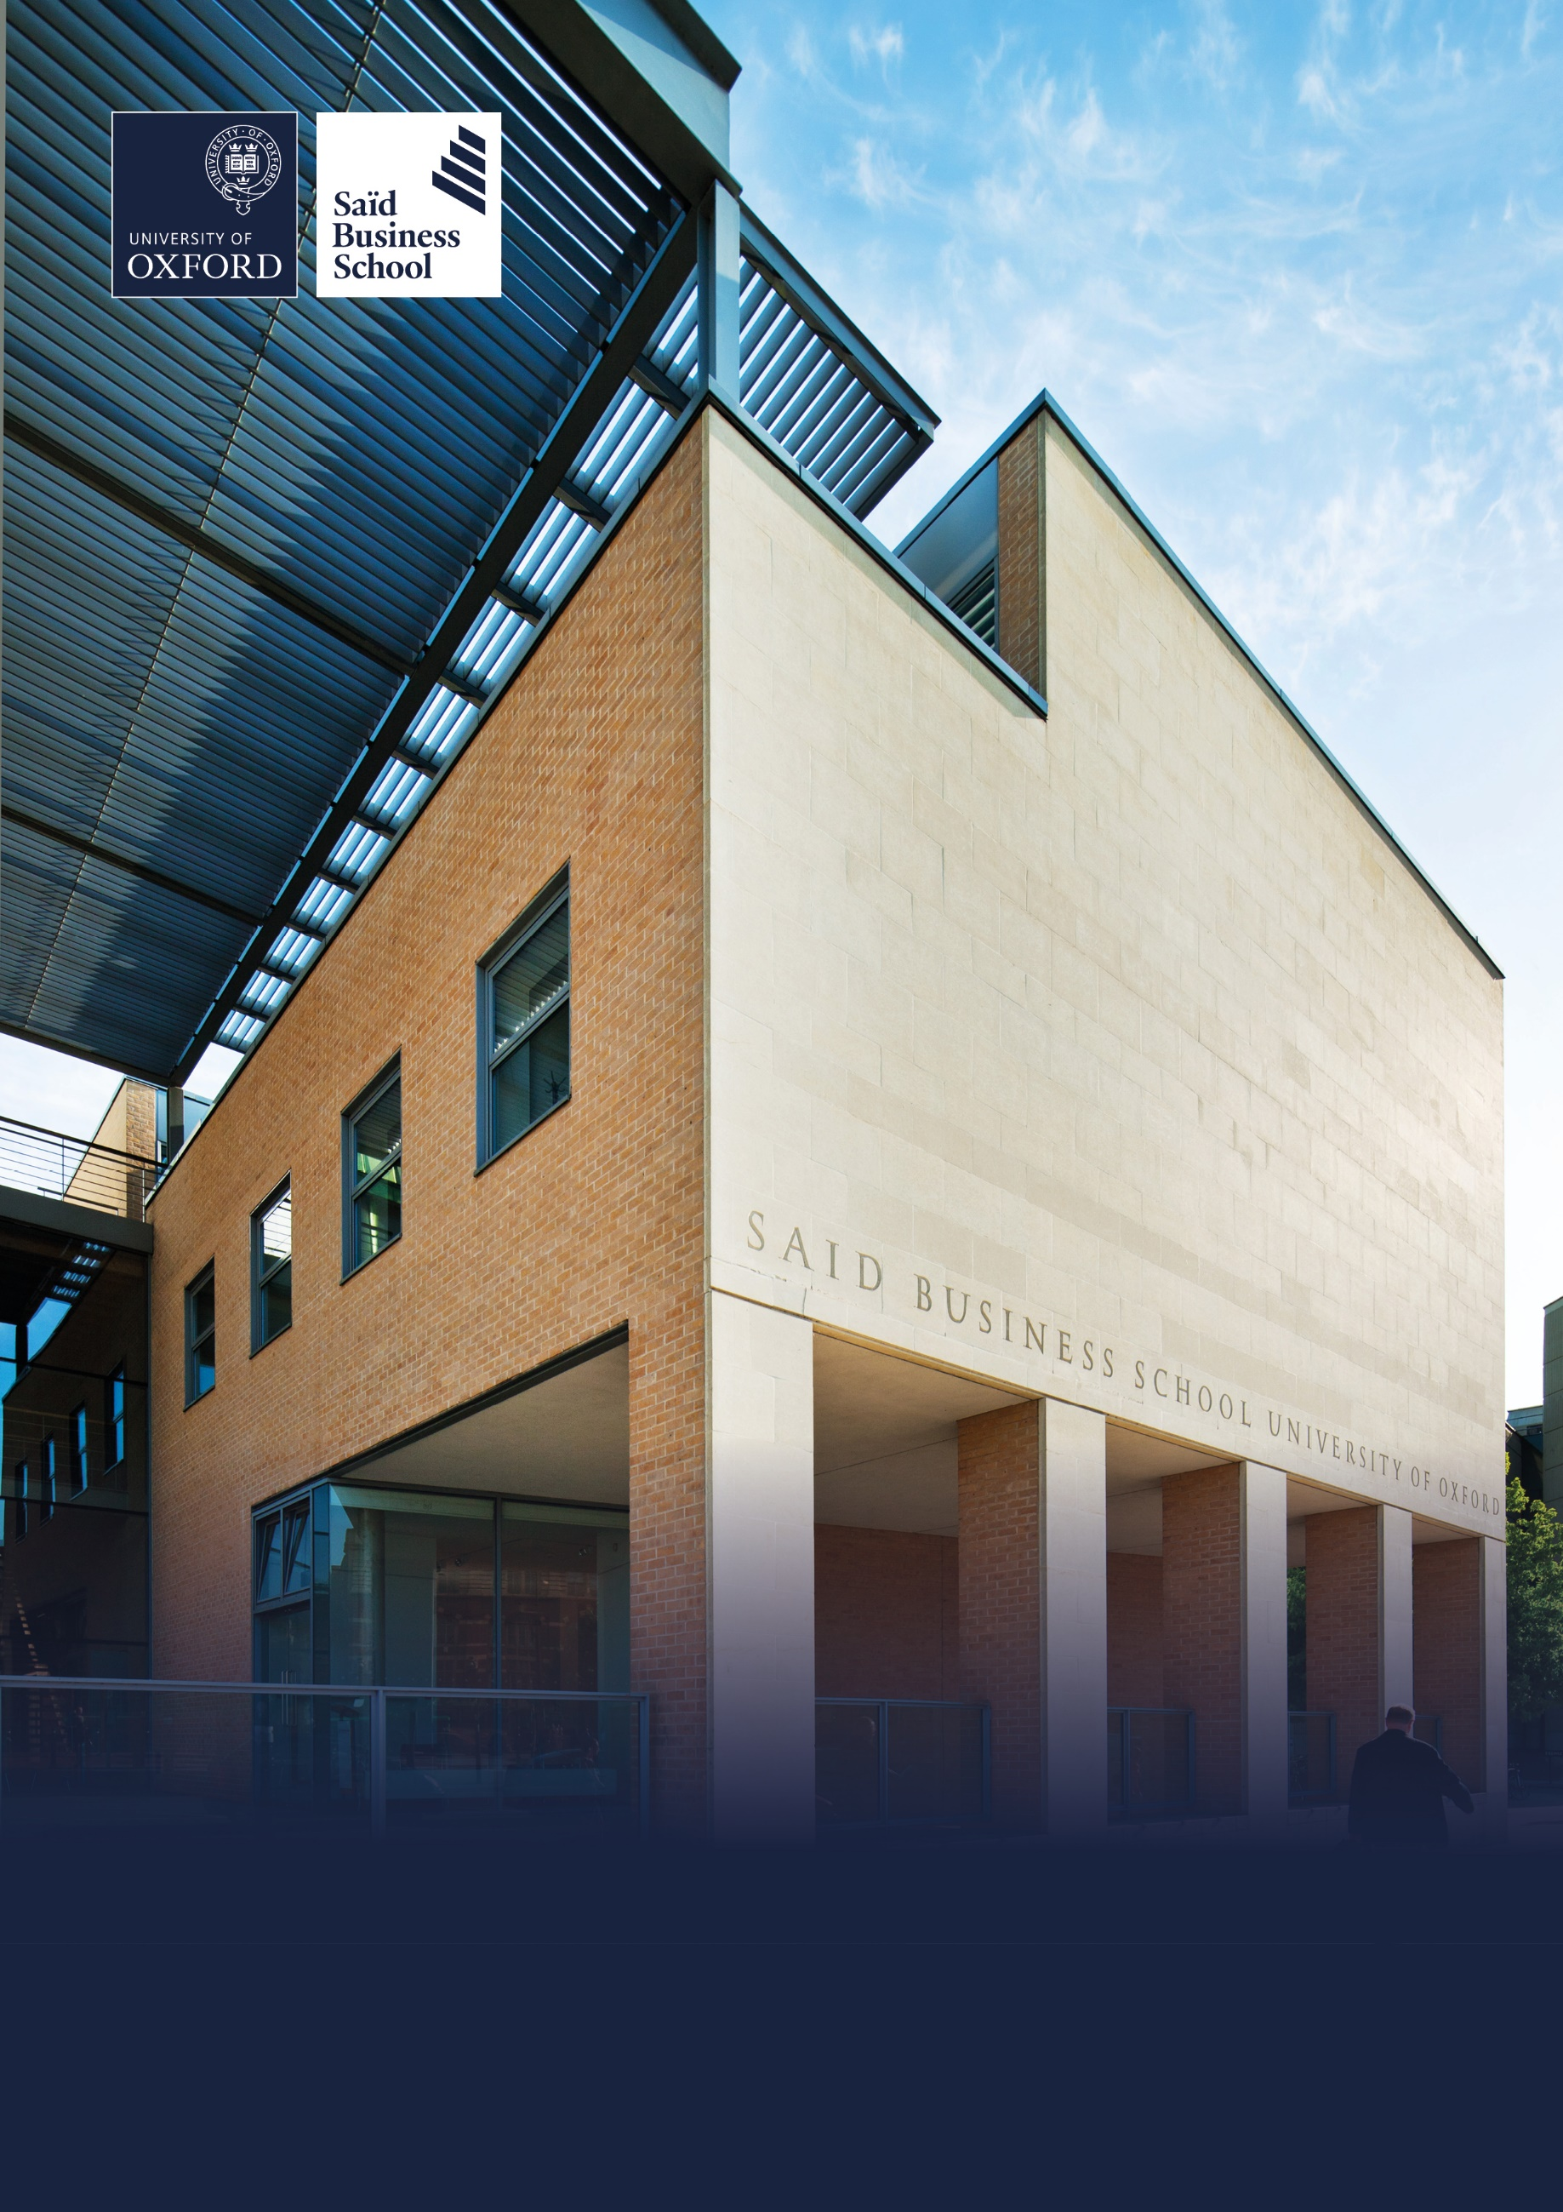

Hybrid (two days per week onsite), Park End Street, Oxford
Grade 9: £56,623 -£65,336 per annum including the Oxford University weighting of £1,730 per annum
Permanent, full time (36.5 hours per week)
Reporting to: Chief Digital and Information Officer
Saïd Business School, Social Sciences Division, University of Oxford
Associate Director, Product Development & Delivery


The role
The School’s Digital and Information Services (D&IS) Department provides technology, services, skill and resources fitting for a business school operating in the top schools globally, as well as innovation and cutting-edge IT and Digital solutions to enhance the School’s competitive position across the spectrum of its work.

The scope of the Department covers a wide range of strategic and support functions, including IT and Digital governance and direction-setting, management and delivery of the institution’s IT and Digital development portfolio, Product Lifecycle and a spectrum of IT and Digital related services including Audio Visual, Education Technology, Web Development, Project Management, front line Help Desk Services, Infrastructure Support and Maintenance and Information Security, Risk and Compliance. The Department enables all those undertaking study at the School – from senior executives to postgraduate students, faculty and staff, to exploit the maximum value from digital information and technology, in order to deliver the School’s mission to be a world class business school community, embedded in a world class university, tackling world scale problems.

As a leading and influential member of the D&IS Senior Management Team, you will provide hands on support and with Product Development and Delivery Team which currently consists of 10FTE and covers c300 products and applications including core and business critical products such as Salesforce, M365, Canvas, Eduframe and Tableau. You will support the CDIO in leading the management, development and delivery of the School’s annual Investment Review Board IT and Digital Development agenda, to ensure successful implementation to deliver business benefit. This will involve maintaining a budgeted, flexible and viable programme of projects (typically c30+ projects with a budget of c£1m) which aligns to the strategic goals resources and budgets of the School and meets the School’s future needs.

You will also drive the product portfolio, working with product owners across the School to ensure product roadmaps are in line with strategy and business needs and dovetail into the Investment Review Board IT and Digital development budget.

This will include pro-actively building, prioritising and managing the Investment Review Board IT and Digital Development Agenda by liaising with all stakeholders across the School, scoping out new development requests and assessing against a fully developed and accepted project assessment criteria to ensure all accepted projects are in alignment with the strategic direction of the School.
The Investment Review Board IT and Digital Development Agenda is likely to be under continual change, requiring constant orchestration, feasibility assessment, resource planning and budget management.

This will require the Associate Director of Product Development and Delivery to foster and maintain excellent working relationships with the Investment Review Board (IRB) and key stakeholders within and across the School to ensure a shared understanding of strategic needs, development project demand and technology-enabled business opportunities.

You will also manage the product portfolio to bring about consistent ways of working across product development, to include the standardisation of testing, release management and development. Working with Product Owners, you will ensure product roadmaps reflect our platform first mission and are in line with the digital strategy.

You will build upon the product management maturity across the School, using best practice and telling the story to instil a change mindset.

Key relationships
CDIO
Associate Director of Service Delivery and Operations
Associate Director of Web Development and Education Technology
Information Security, Risk and Compliance Manager
The Investment Review Board (IRB).
Directors of Student and Programme Services, Faculty Services, Marketing and Communications, Estates, Finance, HR, Open Programmes, Oxford Said Online and Custom Executive Education.
Product Owners
Heads of other departments across the School.
Faculty and staff groups as well as end user/customer representatives.
Central University Purchasing and Legal
Senior account directors and managers of external third-party solution providers, partners and contracting agencies.

Responsibilities

Run a development portfolio across our major platforms, including Salesforce, Office365, Canvas, Eduframe and Tableau, core internal systems for HR, service desk and academic services.
Work with product owners to progress, develop and realise their roadmaps and benefits.
Run an outsourced Salesforce Product team to support, develop and maintain the product during BAU and project life cycles.
Consolidate our application portfolio onto major platforms, ensuring the full TCO is understood with appropriate support and maintenance in place. Working with the business to ensure timeliness, working with problem statements and strategic goals instead of requirements.
Product delivery and support in line with the approved School and Digital strategy.
Testing, release management and development standardisation on major platforms.

Agile standardisation across the School, leading the way in the move from waterfall where applicable and appropriate.
To support the IRB in leading, setting, managing and maintaining the School’s annual IT and Digitsl Development Agenda, ensuring the overall direction, priorities and development are aligned with the strategic vision of the School and D&IS Team.
To manage, motivate and develop staff in the D&IS Product Development and Delivery Team which currently comprises of 7 Project Managers, 2 Business Analyst and 1 UX as well as numerous external third-party on-shore and off-shore application, software and solution providers.
To lead, manage and prioritise the work of the D&IS Product Development and Delivery Team to ensure the provision of effective project management, systems development services and successful delivery of the School’s annual Investment Review Board IT and Digital Development Agenda (typically c30 projects per annum with an annual budget of c£1m).
To develop, manage and ensure adherence to best practice project management and governance protocols and procedures, covering all aspects of the School’s project management and systems development services.
To lead and oversee the delivery of the annual Investment Review Board IT and Digital Development Agenda to agreed budgets, timescales and quality, ensuring all solutions are appropriately contracted, supported and secure
To ensure that all project documentation meets the required quality standards.
To manage the Investment Review Board IT and Digital Development Agenda pipeline, demand, resource, capacity and schedule proactively managing and highlighting any potential resource dependencies, risks, issues, conflicts or synergies between projects.
To conduct regular project management and project progress reviews, ensuring that lessons learned are captured and shared across the team.
To build strong and successful relationships across the business units within the School to generate sponsorship, engagement and ownership of projects to ensure successful delivery and post implementation adoption and exploitation.
To work with the business units and end users for successful implementation and transition into BAU ensuring appropriate support, knowledge and skills are in place for ongoing usage and benefits realisation.
Working with the Project Management team to ensure excellent stakeholder management, including regular communication, planning, project reporting, budget management and risk/issue management.
To ensure that all project activities operate within the policies, procedures and terms of engagement of the School.
To manage, monitor and approve all budgeted project expenditures, ensuring that the projects operate within the approved budget, ensuring that any annual recurring cost is captured and provisioned in the IT Operational Budget.
To lead, manage and negotiate with external partners, contractors and other suppliers for the provision of efficient, value for money and cost-effective third-party solutions to support the School’s delivery of the annual development agenda and development services.
To work with the CDIO in setting and managing agreed performance levels and targets for the School’s Product Development and Delivery Team, and to advise the CDIO on the staffing levels and skills required to meet these targets.
As an important and influential member of the IT Senior Management Team to provide assistance in the general management of the Department as may be required.
To undertake any other duties that may be required from time to time at the request of the CIO.

Selection criteria

Essential selection criteria
- Proven experience in delivering a successful porfolio of development activities within a complex, multi stakeholder organisation.
- Proven experience in Governance, Product Ownership and Management in line with business strategy.
- Proven experience in development and delivery methodologies.
- Proven experience of operating effectively and with confidence at all levels of the organisation.
- Able to demonstrate significant and positive business outcomes from projects delivered in previous roles.
- Ability to engage, develop, collaborate with team members and the wider business, building trust and confidence, especially at senior levels.
- Agile practitioner and evangelist
- Able to deliver to the bigger picture at the same time as attending to detail.
- Ability to identify and manage connections, synergies and dependencies across projects.
- Demonstrable drive, tenacity, resilience and ability to see things through to successful completion.
- Good negotiation and conflict management skills.
- Excellent and proven track record of delivery.
- Excellent and proven experience of budget management and control skills.
- Excellent and proven experience of planning skills.
- Excellent communication (verbal, written, listening) skills with the ability to relate to users at all levels of the organisation and with external partners/suppliers.
- Ability to manage uncertainty and understand the impact of this on the IT Development Agenda and
- other areas of the Department’s services.
- Ability to work under pressure in a busy and varied environment.
- A high level of education to graduate level or equivalent.

Desirable selection criteria
- Product Management Agile PM

- Certificate or Diploma in Project and Programme Management (DPPM)

- Knowledge of Oracle Financials.

Pre-employment screening

Standard checks
If you are offered the post, the offer will be subject to standard pre-employment checks. You will be asked to provide: proof of your right-to-work in the UK; proof of your identity; and (if we haven’t done so already) we will contact the referees you have nominated. If you have previously worked for the University we will also verify key information such as your dates of employment and reason for leaving your previous role with the department/unit where you worked. You will also be asked to complete a health declaration so that you can tell us about any health conditions or disabilities for which you may need us to make appropriate adjustments.


Please read the candidate notes on the University’s pre-employment screening procedures at Pre-employment checks (https://www.ox.ac.uk/about/jobs/explore-our-careers/applications-process/pre-employment-screening).


About the University of Oxford
Welcome to the University of Oxford. We aim to lead the world in research and education for the benefit of society both in the UK and globally. Oxford’s researchers engage with academic, commercial and cultural partners across the world to stimulate high-quality research and enable innovation through a broad range of social, policy and economic impacts.

We believe our strengths lie both in empowering individuals and teams to address fundamental questions of global significance, while providing all our staff with a welcoming and inclusive workplace that enables everyone to develop and do their best work. Recognising that diversity is our strength, vital for innovation and creativity, we aspire to build a truly diverse community which values and respects every individual’s unique contribution.

While we have long traditions of scholarship, we are also forward-looking, creative and cutting-edge. Oxford is one of Europe’s most entrepreneurial universities and we rank first in the UK for university spin-outs, and in recent years we have spun out 15-20 new companies every year. We are also recognised as leaders in support for social enterprise.

Join us and you will find a unique, democratic and international community, a great range of staff benefits and access to a vibrant array of cultural activities in the beautiful city of Oxford. For more information, please visit About the University of Oxford (https://www.ox.ac.uk/about).

Saïd Business School
Saïd Business School blends the best of new and old. We are a vibrant and innovative business school, but yet deeply embedded in an 800 year old world-class university. We create programmes and ideas that have global impact. We educate people for successful business careers, and as a community seek to tackle world-scale problems.

We deliver cutting-edge programmes, including the highly regarded MBA, Executive MBA, a number of specialist MScs, a portfolio of custom and open programmes and accredited diplomas for executives, and we undertake ground-breaking research that transform individuals, organisations, business practice and society. We are an international and outward looking School with our programme participants coming from more than 50 countries.

We seek to be a world-class business school community, embedded in a world-class University, tackling world-scale problems.

Sustainability
Saïd Business School is committed to the highest standards of environmental sustainability, preserving the planet for future generations and acting in a socially sustainable manner. As an employee you are expected to uphold these commitments in accordance with our Environmental Policy. You can learn more about our organisation’s sustainability efforts at Sustainability | Saïd Business School (https://www.sbs.oxford.edu/about-us/school/sustainability).

Diversity and Inclusion
Oxford Saïd is committed to fostering an inclusive culture which promotes equality, values diversity and maintains a working, learning and social environment in which the rights and dignity of all its staff and students are respected. We recognise that the broad range of experiences that a diverse staff and student body brings strengthens our research and enhances our teaching, and that in order for Oxford to remain a world-leading institution we must continue to provide a diverse, inclusive, fair and open environment that allows everyone to grow and flourish.

Oxford Saïd holds a bronze Athena Swan award to recognise advancement of gender equality: representation, progression and success for all.

Our Values
To better understand our Values, what behaviours demonstrate them and how they are involved in your everyday work we have created the below descriptors.

Transformational
We challenge constructively, provoke thought, and influence and inspire others to develop.

Respectful
We are caring, supportive, appreciative, embrace difference and value each other's opinions.

Entrepreneurial
We embrace and encourage change and innovation. We are creative, flexible and brave.

Collaborative
We are stronger together. We are inclusive, approachable, listen to others and value good communication.

Purposeful

We are a community who believe in sustainable growth, and are responsible, principled and transparent.

Excellence
We are professional, focused and aligned, and have a responsibility to do the very best we can.

Wellbeing
Saïd Business School acknowledge the importance of wellbeing, in enabling people to thrive at work and ensure a work-life balance. It provides a number of initiatives to help support wellbeing and would encourage you to participate. At an individual level, wellbeing means recognising what helps us remain resilient and taking appropriate steps. If we experience difficulties, doing our best to rectify them and making our line manager aware of aspects that they could support us with.

Further information about Saïd Business School is available at Saïd Business School (www.sbs.oxford.edu).

Social Sciences
Oxford Saïd is a department within the Social Sciences Division, one of four academic Divisions in the University, each with considerable devolved budgetary and financial authority; and responsibility for providing a broad strategic focus across its constituent disciplines.

The Social Sciences Division represents the largest grouping of social sciences in the UK: home to a number of outstanding departments and to the internationally ranked Law Faculty; all are committed to research to develop a greater understanding of all aspects of society, from the impact of political, legal and economic systems on social and economic welfare to human rights and security. That research is disseminated through innovative graduate programmes and enhances undergraduate courses. For more information please visit Social Sciences Division (https://www.socsci.ox.ac.uk).


How to apply
Applications are made through our online recruitment portal. Information about how to apply is available on our Jobs website at How to apply (https://www.ox.ac.uk/about/jobs/explore-our-careers/applications-process/how-to-apply).

Your application will be judged solely on the basis of how you demonstrate that you meet the selection criteria stated in the job description.

As part of your application you will be asked to provide details of two referees and indicate whether we can contact them now.

You will be asked to upload a CV and a supporting statement. The supporting statement must explain how you meet each of the selection criteria for the post using examples of your skills and experience. This may include experience gained in employment, education or during career breaks (such as time out to care for dependants).

Please upload all documents as PDF files with your name and the document type in the filename.

All applications must be received by midday UK time on the closing date stated in the online advertisement.

Information for internal candidates
If you currently work for the University please note that:

- As part of the referencing process, we will contact your current department to confirm basic employment details including reason for leaving.

- Although employees may hold multiple part-time posts, they may not hold more than the equivalent of a full time post. If you are offered this post, and accepting it would take you over the equivalent of full-time hours, you will be expected to resign from, or reduce hours in, your other post(s) before starting work in the new post.

- Before applying for this post, you are advised to read the Internal Mobility Principles (https://unioxfordnexus.sharepoint.com/sites/OXINTRANET-working-here/SitePages/internal-mobility-principles.aspx). The principles promote good practice for moving into professional services roles and are designed to provide clarity on expectations for managers and individuals.

Information for priority candidates
A priority candidate is a University employee who is seeking redeployment because they have been advised that they are at risk of redundancy, or on grounds of ill-health/disability. Priority candidates are issued with a redeployment letter by their employing department(s).

If you are a priority candidate, please ensure that you attach your redeployment letter to your application (or email it to the contact address on the advert if the application form used for the vacancy does not allow attachments).

If you need help
Application FAQs, including technical troubleshooting advice is available at Support with online applications (https://www.ox.ac.uk/about/jobs/explore-our-careers/applications-process/support-with-online-applications).

Non-technical questions about this job should be addressed to HR.Recruitment@sbs.ox.ac.uk.

To return to the online application at any stage, please go to How to apply (https://www.ox.ac.uk/about/jobs/explore-our-careers/applications-process/how-to-apply).

Please note that you will receive an automated email from our online recruitment portal to confirm receipt of your application. Please check your spam/junk mail if you do not receive this email.


Important information for candidates

Data Privacy
Please note that any personal data submitted to the University as part of the job application process will be processed in accordance with the GDPR and related UK data protection legislation. For further information, please see the University’s Privacy Notice for Job Applicants at Job applicant privacy policy (https://compliance.admin.ox.ac.uk/job-applicant-privacy-policy).

The University’s Policy on Data Protection is available at Data protection policy (https://compliance.admin.ox.ac.uk/data-protection-policy).

The University’s policy on retirement
The University operates an Employer Justified Retirement Age (EJRA) for very senior research posts at grade RSIV/D35 and clinical equivalents E62 and E82 of 30 September before the 70th birthday.

For existing employees, any employment beyond the retirement age is subject to approval through the procedures. Please see The EJRA (https://unioxfordnexus.sharepoint.com/sites/OXINTRANET-working-here/SitePages/the-ejra.aspx).

There is no normal or fixed age at which staff in posts at other grades have to retire. Staff at these grades may elect to retire in accordance with the rules of the applicable pension scheme, as may be amended from time to time.

Equality of opportunity
The University of Oxford is committed to equal opportunity and to being a place where everyone belongs and is supported to succeed. We recognise how the diversity of our community enriches our ability to deliver on our academic mission.

We welcome applications from individuals from all backgrounds, including those underrepresented within higher education. No applicant or member of staff shall be unlawfully discriminated against on the basis of age, disability, gender reassignment, marriage or civil partnership, pregnancy or maternity, race, religion or belief, sex or sexual orientation.

Employment with the University and progression within employment will be determined according to personal merit and the application of criteria related to the duties and conditions of the post. In all cases, the primary consideration will be the ability to perform the job.

As stated in the University’s Equality Policy and Equality, Diversity and Inclusion Strategic Plan, our commitment to equality and diversity goes hand in hand with our commitment to academic freedom and free speech.


Oxford Saïd Exclusive Benefits

Wellbeing initiatives
Oxford Saïd runs a fortnightly Wellbeing Wednesday when staff are encouraged to take time (one hour for full-time staff and half an hour for part-time staff) during the working day to focus on their wellbeing in addition to their lunch break. We also have excellent catering facilities that provide a high standard of food, including healthy eating and vegetarian options at a subsidised cost.

Staff Summer and Christmas parties
Oxford Saïd like to reward all of their staff for their great work and their Christmas and Summer parties are our way of saying thank you. The Christmas party is for all staff and the summer party is for staff and their immediate family members, because we know how important family is to all of us.

Employee Assistance provider
Spectrum.Life is an employee assistance and wellbeing consultancy that works in partnership with the Business School to provide staff and their immediate family with a free 24-hour per day helpline providing confidential information and counselling services on personal issues.

University of Oxford Benefits

Annual leave
38 days (inc. public holidays). Long service additional annual leave – up to 5 days per annum, pro rata for part time employees. Previous service within higher education sector can be recognised. An additional scheme enables staff to request to purchase up to 10 additional days in each holiday year.

Salary and salary sacrifice schemes
The University salary and grading structure allows for annual incremental progression until a scale-bar point is reached. This incremental progression is automatic. Additionally, there are salary sacrifice schemes for bicycles and electric cars. See Working here (https://www.ox.ac.uk/about/jobs/working-here).

Pension
If you are on an academic or academic related pay scale (grade 6 or above), you are automatically a member of USS. Employer contribution is 14.5% and Employee contribution is 6.1%.

If you are on a pay scale other than academic or academic related (grade 1-5) you are automatically a member of OSPS. Employee contribution can be between 4%- 8% and Employer contribution 10%-14%.

University discounts
All University staff can purchase a TOTUM discount card for £14.99 for 12 months (£24.99 for 2 years, £34.99 for 3 years) which gives access to numerous exclusive offers and discounts from many popular retailers. There are a wide range of other discounts from external companies available using a university card.

University Club
Membership of the University Club is free for all University staff. The University Club offers social, sporting and hospitality facilities. Staff can also use the University Sports Centre on Iffley Road at discounted rates, including a fitness centre, powerlifting room and swimming pool. See The University Club (www.club.ox.ac.uk) and Oxford University Sport (https://www.sport.ox.ac.uk).

Access to Oxford buildings
Free access to a number of Oxford colleges, Botanic Gardens, Harcourt Arboretum, Wytham Woods and discount at numerous restaurants/shops.



Saïd Business School
University of Oxford
Park End Street
Oxford, OX1 1HP
Saïd Business School, University of Oxford
United Kingdom
www.sbs.oxford.edu

All information is correct at the time of going to press.

Please check our website for the most up-to-date information.

